REPORT ON THE AYOVE PROJECT ORGANISED BY MAYO IN COLLABORATION WITH PHIRC
INTRODUCTION
It all started with the establishment of the African Health Solutions Network to implement solutions to the health problems of African nations. This was a collaborative effort between Public Health Impact Research Centre (PHIRC), Nigeria and African Higher Education Research Organisation (AFRIHERO) of UK. The collaborative effort was based on the premise that often when African health issues are discussed at international fora, the impression one gets is that majority of Africans are helpless in finding solutions to their own. In an attempt to prove this ideology wrong, the African Health Solutions Network sought to mobilise the abundance of human, financial and material resources that exist within Africans in a unique and transparent fashion, to solve many developmental problems with a specific focus on health-related Millennium Development Goals. The official launch of the African Health Solutions Network took place at the 28th International Congress of the Medical Women’s International Association in Munster, Germany in July 2010.
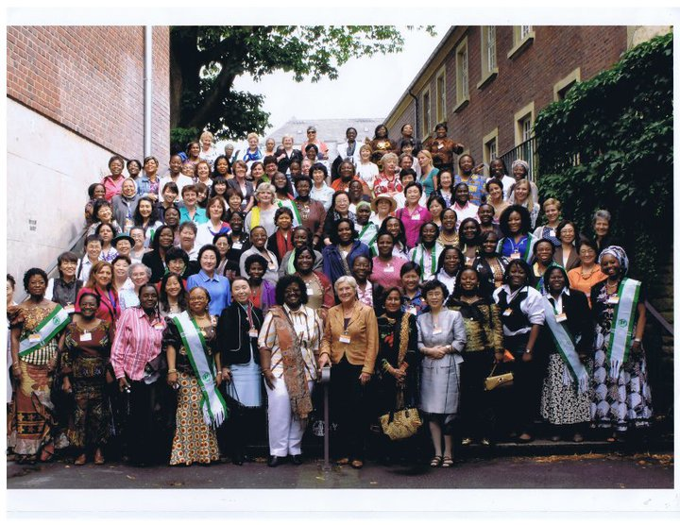
DELEGATES AT THE MEDICAL WOMEN’S INTERNATIONAL CONGRESS MUNSTER, GERMANY (JULY 2010) WHERE THE AFRICAN HEALTH SOLUTIONS NETWORK WAS LAUNCHED
Back home in Nigeria, the Coordinator of the Network, Dr. M. I. Oseji sought to domesticate the AYOV project by establishing the Nigerian Health Solutions Network. In August, 2011, fifty-five people signed up for the Asaba Declaration which is a call for people to join the Nigerian Health Solutions Network by embarking on an "Adopt Your Own Village (AYOV)" project. This Network was initiated by PHIRC, in collaboration with the Centre for African Peace and Conflict Resolution, California State University, Sacramento. By the 6 month anniversary of the launching of the network, four individuals and one organisation had carried out projects in their communities and sent in reports. The target is to reach 10,000 communities across Nigeria.
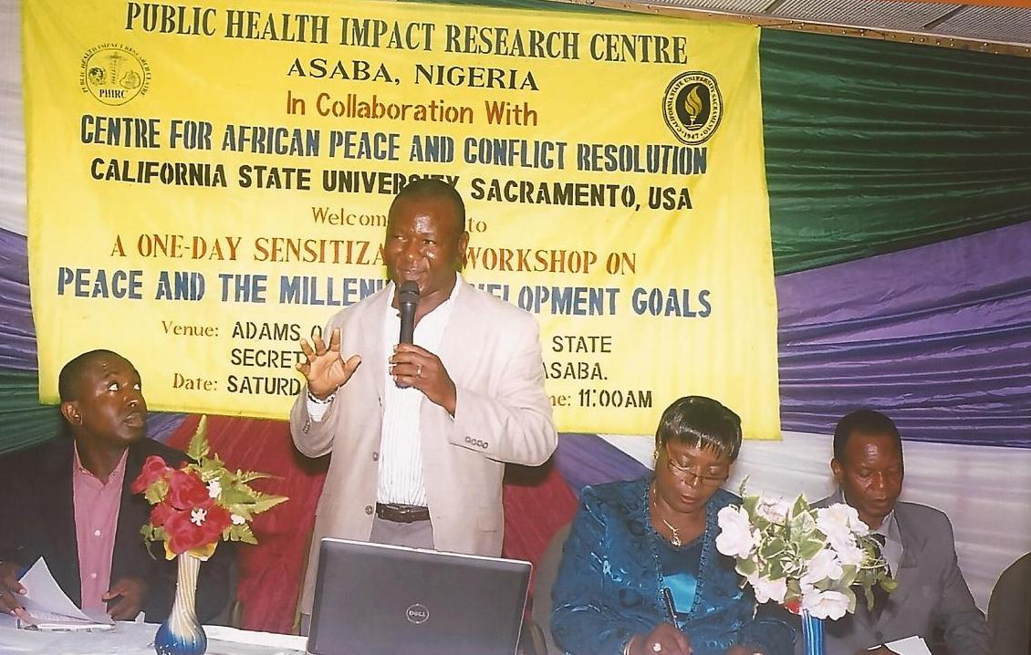
PROF. UWAZIE GIVING A LECTURE ON PEACE EDUCATION IN ASABA, AUGUST 2011

Steps for embarking on an AYOV Project
- Get baseline data about Millennium Development Goals indicators in your locality of origin (preferably your own ward).
- Focus on programmes and activities that would improve the worst indices. Select a project and determine how to raise fund and any other resources for the implementation.
- Find out what other individuals and organisations are doing so that activities can be properly coordinated and duplication of effort avoided
- Collaborate with and involve the local government authorities in-charge of the area to provide a window of opportunity for sustainability of the project
- Write a report of the activity and send to relevant stakeholders.
- Support the celebration of notable health days for advocacy and awareness creation
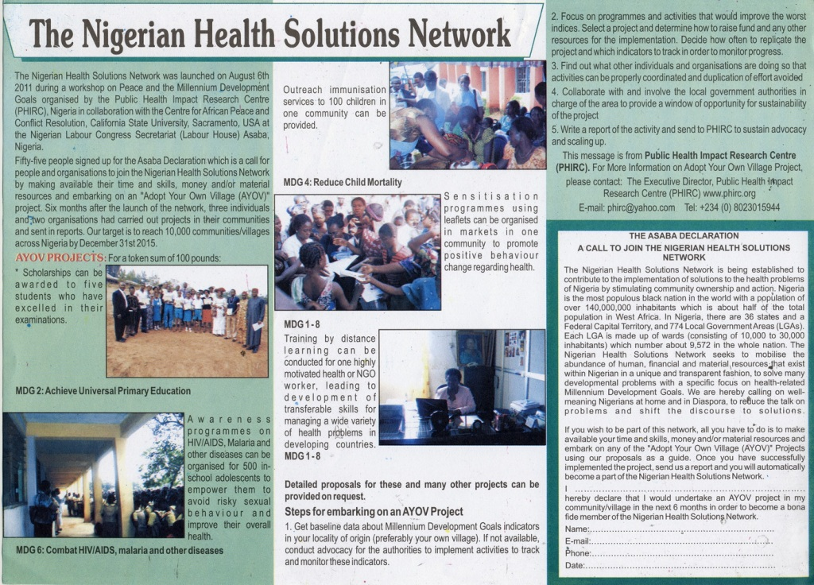
NIGERIAN HEALTH SOLUTION FLIER

THE ASABA DECLARATION
A CALL TO JOIN THE NIGERIAN HEALTH SOLUTIONS NETWORK
The Nigerian Health Solutions Network is being established to contribute to the implementation of solutions to the health problems of Nigeria by stimulating community ownership and action. Nigeria is the most populous black nation in the world with a population of over 140,000,000 inhabitants which is about half of the total population in West Africa. In Nigeria, there are 36 states and a Federal Capital Territory, and 774 Local Government Areas (LGAs). Each LGA is made up of wards (consisting of 10,000 to 30,000 inhabitants) which number about 9,572 in the whole nation. The Nigerian Health Solutions Network seeks to mobilise the abundance of human, financial and material resources that exist within Nigerian in a unique and transparent fashion, to solve many developmental problems with a specific focus on health-related Millennium Development Goals. We are hereby calling on well-meaning Nigerians at home and in Diaspora, to reduce the talk on problems and shift the discourse to solutions. If you wish to be part of this network, all you have to do is to make available your time and skills, money and/or material resources and embark on any of the "Adopt Your Own Village (AYOV)" Projects using our proposals as a guide. Once you have successfully implemented the project, send us a report and you will automatically become a part of the Nigerian Health Solutions Network.
I ………………………………………………………………….. hereby declare that I would undertake an AYOV project in my community in the next 6 months in order to become a bona fide member of the Nigerian Health Solutions Network.
Name:………………………………………………………….
E-mail:…………………………………………………………
Phone:…………………………………………………………

In August 2014, Dr. Oseji shared the vision of the Nigerian Health Solutions Network among some Nigerian stakeholders in Paris, France.

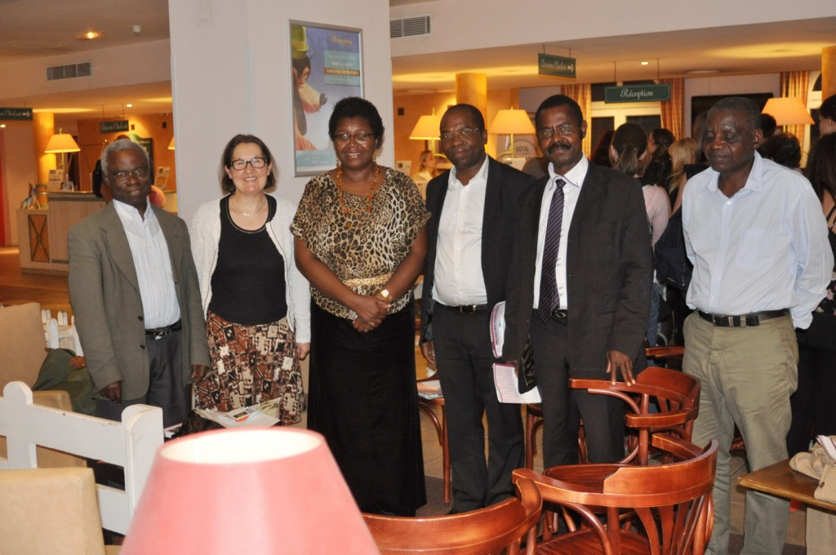
SENSITISATION ON THE NIGERIAN HEALTH SOLUTIONS NETWORK IN PARIS, FRANCE AUGUST 2014

In August 2015, at the Annual Family Conference of the Overseas Fellowship of Nigerian Christians, Dr. Oseji gave a short presentation on the Nigerian Health Solutions Network. It was at that event, that Dr. A. Eni-Olotu, Founder of Mayo Lifelong Learning and Resource Centre for Children Youth and Carers took interest in the AYOV Project and discussed the possibility of carry out a project to promote child health.
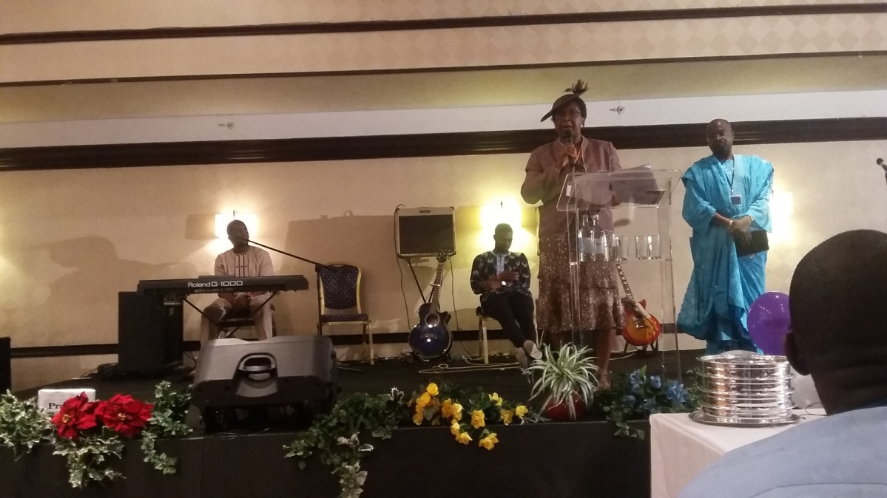 DR. OSEJI GIVING A PRESENTATION ON THE NHSN AT THE OFNC VCONFERENCE IN BIRMINGHAM, UK AUGUST 2015
The November 2015 round of the celebration of Maternal, Newborn Child Health Week was chosen as an opportunity to support sensitization on maternal and child health interventions through the use of fliers. The flyers were sponsored by Mayo Lifelong Learning and Resource Centre for Children Youth and Carers herein after referred to as MAYO. The project was a collaborative effort between MAYO, PHIRC and the Ekiti State government.
An application was written to and approval obtained from the appropriate authorities in Ekiti State following which planning meetings were held with the officials prior to the event date.
The awareness program was originally planned for implementation in Ejiyan – Ekiti. However, this was eventually changed to Okeyinmi Comprehensive Health Centre, Ado – Ekiti at the instance of Ekiti state government officials.
On the day of event, about 250 mothers were in the clinic including pregnant women and market women. Many fathers were there. In attendance were Ministry of health officials, the State Educator, and a representative of the WHO. After the initial introductory speeches, the Mayo Director, Princess Matron Olajide, gave her presentation on the flyers which were thereafter distributed.
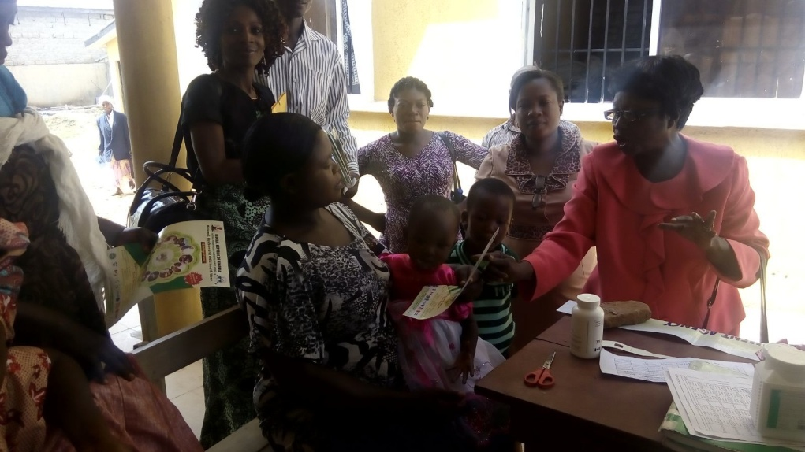
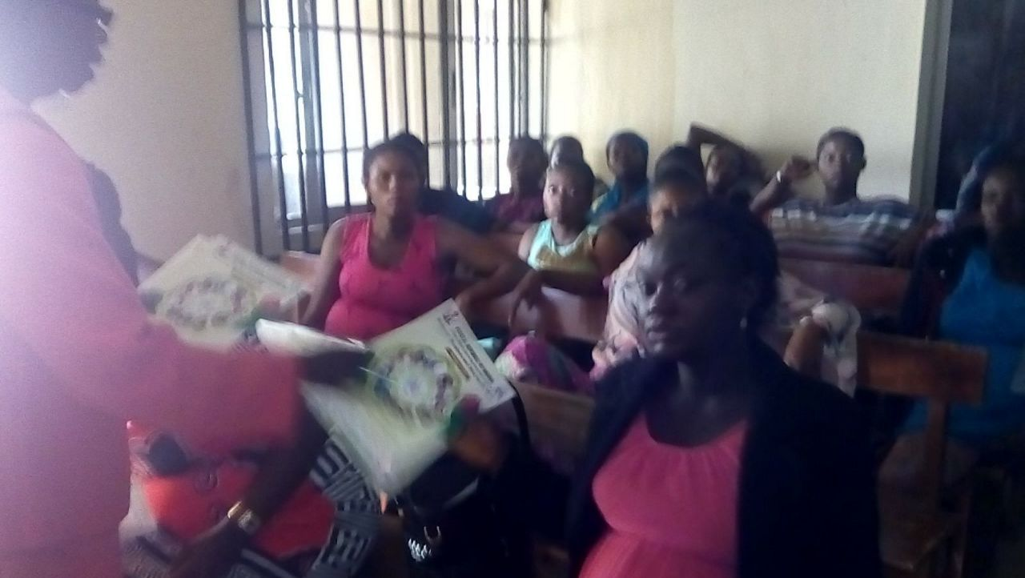
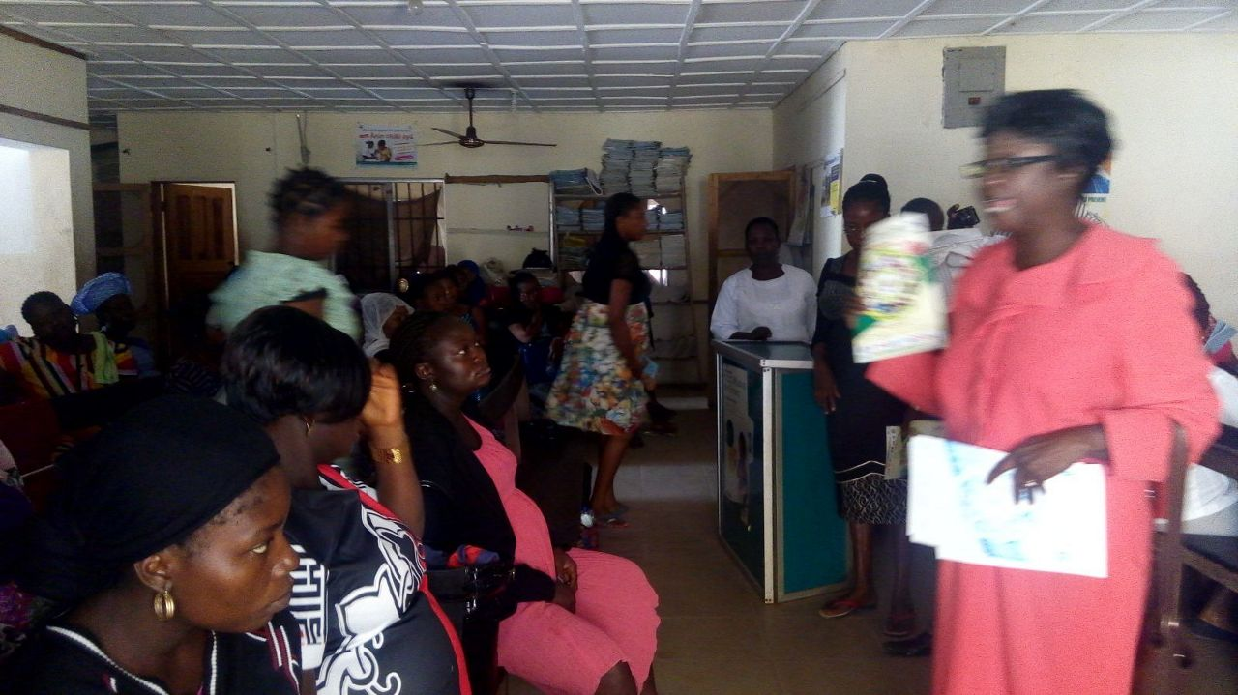 MATRON OLAJIDE, GIVING A PRESENTATION AS SHE DISTRIBUTES THE FLIERS IN A HEALTH CENTRE
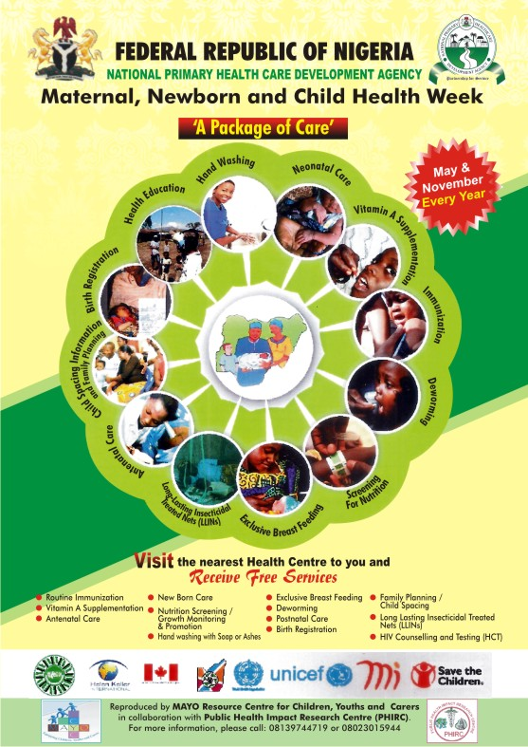
MATERNAL AND NEWBORN CHILD HEALTH WEEK FLIER
A proposed means of assessing the impact of this and other similar projects is to conduct exit interviews for mothers and care givers that attend Primary Health Centre. See below.

MATERNAL NEWBORN AND CHILD HEALTH WEEK (MNCHW)
EXIT INTERVIEWS FOR CARE GIVERS (PIDGIN)
- For which age pikin suppose to complete Immunization?
- (a) How many months you give your last pikin breast milk?
(b) You dey give breast milk only?
(c) For which age you begin give pap etc.
- You dey use treated mosquito net dey sleep?
- (a) E get any of your pikin wey don take Vitamin A before?
(b) Wetin be the age of that pikin?
- (a) E good make woman come clinic 6 weeks after e don born pikin?
(b) If yes why?
- Which kain support your husband dey give you when you get bele?
- Your pikin dem don get original birth certificate?
- Wetin you dey do or take if you no wan get bele? (you dey do family planning?)
- You don hear about HIV before?
- Wetin woman wey get HIV go do make in pikin wey dey in bele no get HIV?

MATERNAL NEWBORN AND CHILD HEALTH WEEK (MNCHW)
EXIT INTERVIEWS FOR CARE GIVERS (ENGLISH)
- At what age should a child complete Immunization?
- (a) For how many months did you breast feed your last baby?
(b) Did you give only breast milk?
(c) At what age did you start giving pap etc?
- Do you sleep under Insecticide Treated Net?
- (a) Have any of your children received Vitamin A before?
(b) How old are the children?
- (a) Should a woman visit the clinic 6 weeks after delivery?
(b) If so why?
- What type of support does your husband give you when you are pregnant?
- Have you obtained an original birth certificate for all your children?
- How do you space your children? (What Family Planning methods do you use?)
- Have you heard about HIV before?
- How can mothers prevent passing HIV to their unborn children?

APPRECIATION
Our sincere appreciation goes to Dr. A. Eni-Olotu, Dr. Olajide, Matron Olajide and all those who helped to make this project a reality. It is hoped that on reading this report, more individuals and organizations will embark on AYOV projects in their communities to contribute to attaining health for all.

Dr. (Mrs.) M. I. Oseji
Executive Director
Public Health Impact Research Centre
Tel +234(0)8023015944
Website: www.phirc.org

